Common areas explored on cross examination: Qualifications
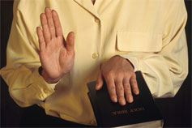
Can you anticipate what you will be asked during cross examination? Here are some common areas.
Qualifications
- Accuracy of CV
- Knowledge
- Skill
- Education/Degrees/Licenses
- Training
- Memberships in societies
- Awards
- Practical experience
- Recentness of experience
- Relevancy of experience
- Credibility
- Marketing activities
- Relationship to retaining party or attorney
- Affiliation with an insurance company
- Conversations with retaining attorney
- Indirect monetary interest
- Prior testimony
- Professional presentations
- Professional and personal writings
Read more about cross-examination from Cross-Examination: The Comprehensive Guide For Experts.

